FCFS(FIRST COME FIRST SERVE)
#include <stdio.h>
int main() {
printf("NAME:RAHUL M MATTI\n" "USN:1BM25CS498\n");
int n, i;
printf("Enter number of processes: ");
scanf("%d", &n);
int AT[n], BT[n], CT[n], TAT[n], WT[n], RT[n];
int current_time = 0;
float avgCT = 0, avgTAT = 0, avgWT = 0, avgRT = 0;
for(i = 0; i < n; i++) {
printf("Enter Arrival Time and Burst Time for P%d: ", i+1);
scanf("%d %d", &AT[i], &BT[i]);
}
for(i = 0; i < n; i++) {
if(current_time < AT[i])
current_time = AT[i];
RT[i] = current_time - AT[i];
CT[i] = current_time + BT[i];
TAT[i] = CT[i] - AT[i];
WT[i] = TAT[i] - BT[i];
current_time = CT[i];
avgCT += CT[i];
avgTAT += TAT[i];
avgWT += WT[i];
avgRT += RT[i];
}
printf("\n%-8s %-14s %-12s %-18s %-18s %-14s %-14s\n",
"PROCESS","ARRIVAL TIME","BURST TIME","COMPLETION TIME",
"TURN AROUND TIME","WAITING TIME","RESPONSE TIME");
for(i = 0; i < n; i++) {
printf("P%-7d %-14d %-12d %-18d %-18d %-14d %-14d\n",
i+1, AT[i], BT[i], CT[i], TAT[i], WT[i], RT[i]);
}
printf("\nAverage CT = %.2f", avgCT/n);
printf("\nAverage TAT = %.2f", avgTAT/n);
printf("\nAverage WT = %.2f", avgWT/n);
printf("\nAverage RT = %.2f\n", avgRT/n);
return 0;
}OUTPUT:-
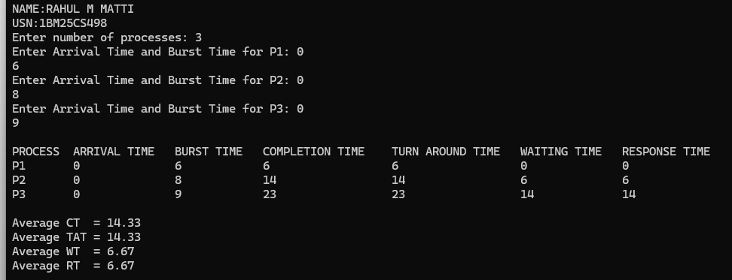

SJF(SHORTEST JOB FIRST)
#include <stdio.h>
int main() {
printf("NAME:RAHUL M MATTI\n" "USN:1BM25CS498\n");
int n, i, pos;
printf("Enter number of processes: ");
scanf("%d",&n);
int AT[n], BT[n], CT[n], TAT[n], WT[n], RT[n], done[n];
int current_time = 0, completed = 0;
float avgCT=0, avgTAT=0, avgWT=0, avgRT=0;
for(i=0;i<n;i++){
printf("Enter AT and BT for P%d: ",i+1);
scanf("%d %d",&AT[i],&BT[i]);
done[i]=0;
}
while(completed < n){
int minBT = 999;
for(i=0;i<n;i++){
if(AT[i] <= current_time && done[i]==0 && BT[i] < minBT){
minBT = BT[i];
pos = i;
}
}
if(minBT == 999){
current_time++;
}
else{
RT[pos] = current_time - AT[pos];
CT[pos] = current_time + BT[pos];
TAT[pos] = CT[pos] - AT[pos];
WT[pos] = TAT[pos] - BT[pos];
current_time = CT[pos];
done[pos] = 1;
completed++;
avgCT += CT[pos];
avgTAT += TAT[pos];
avgWT += WT[pos];
avgRT += RT[pos];
}
}
printf("\n%-5s %-12s %-10s %-15s %-15s %-12s %-12s\n",
"P","ArrivalTime","BurstTime","CompletionTime","TurnAroundTime","WaitingTime","ResponseTime");
for(i=0;i<n;i++)
printf("%-5s %-12d %-10d %-15d %-15d %-12d %-12d\n",
"P", AT[i], BT[i], CT[i], TAT[i], WT[i], RT[i]);
printf("\nAverage CT = %.2f",avgCT/n);
printf("\nAverage TAT = %.2f",avgTAT/n);
printf("\nAverage WT = %.2f",avgWT/n);
printf("\nAverage RT = %.2f\n",avgRT/n);
return 0;
}

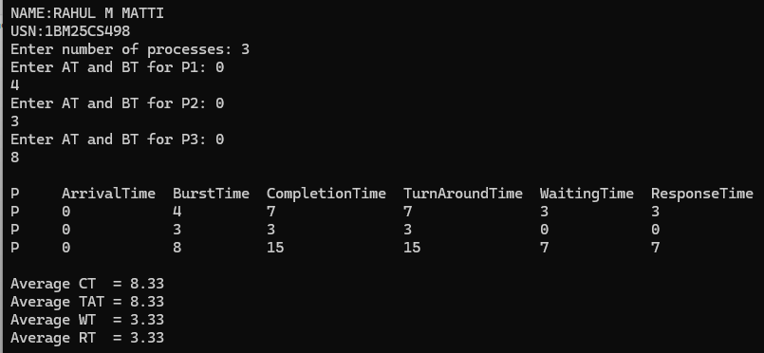
OUTPUT:

SRTF
#include <stdio.h>
int main() {
printf("NAME:RAHUL M MATTI\n" "USN:1BM25CS498\n");
int n;
printf("Enter number of processes: ");
scanf("%d",&n);
int AT[n], BT[n], RT[n], CT[n], TAT[n], WT[n], start[n];
int i, time = 0, completed = 0, min, pos;
float avgCT=0, avgTAT=0, avgWT=0, avgRT=0;
for(i=0;i<n;i++){
printf("Enter AT and BT for P%d: ",i+1);
scanf("%d %d",&AT[i],&BT[i]);
RT[i] = BT[i];
start[i] = -1;
}
while(completed < n){
min = 999;
for(i=0;i<n;i++){
if(AT[i] <= time && RT[i] > 0 && RT[i] < min){
min = RT[i];
pos = i;
}
}
if(min == 999){
time++;
}
else{
if(start[pos] == -1)
start[pos] = time;
RT[pos]--;
time++;
if(RT[pos] == 0){
completed++;
CT[pos] = time;
TAT[pos] = CT[pos] - AT[pos];
WT[pos] = TAT[pos] - BT[pos];
avgCT += CT[pos];
avgTAT += TAT[pos];
avgWT += WT[pos];
avgRT += (start[pos] - AT[pos]);
}
}
}
printf("\n%-5s %-12s %-10s %-15s %-15s %-12s %-12s\n",
"P","ArrivalTime","BurstTime","CompletionTime","TurnAroundTime","WaitingTime","ResponseTime");
for(i=0;i<n;i++)
printf("%-5s %-12d %-10d %-15d %-15d %-12d %-12d\n",
"P", AT[i], BT[i], CT[i], TAT[i], WT[i], start[i]-AT[i]);
printf("\nAverage CT = %.2f",avgCT/n);
printf("\nAverage TAT = %.2f",avgTAT/n);
printf("\nAverage WT = %.2f",avgWT/n);
printf("\nAverage RT = %.2f\n",avgRT/n);
return 0;
}
OUTPUT
